**Kafka Code and snapshots**

First start the zookeeper by typing the below command in its directory.

**cd C:\Users\suraj\Downloads\apache-zookeeper-3.5.9-bin\bin**

C:\Users\suraj\Downloads\apache-zookeeper-3.5.9-bin\bin>**zkserver**

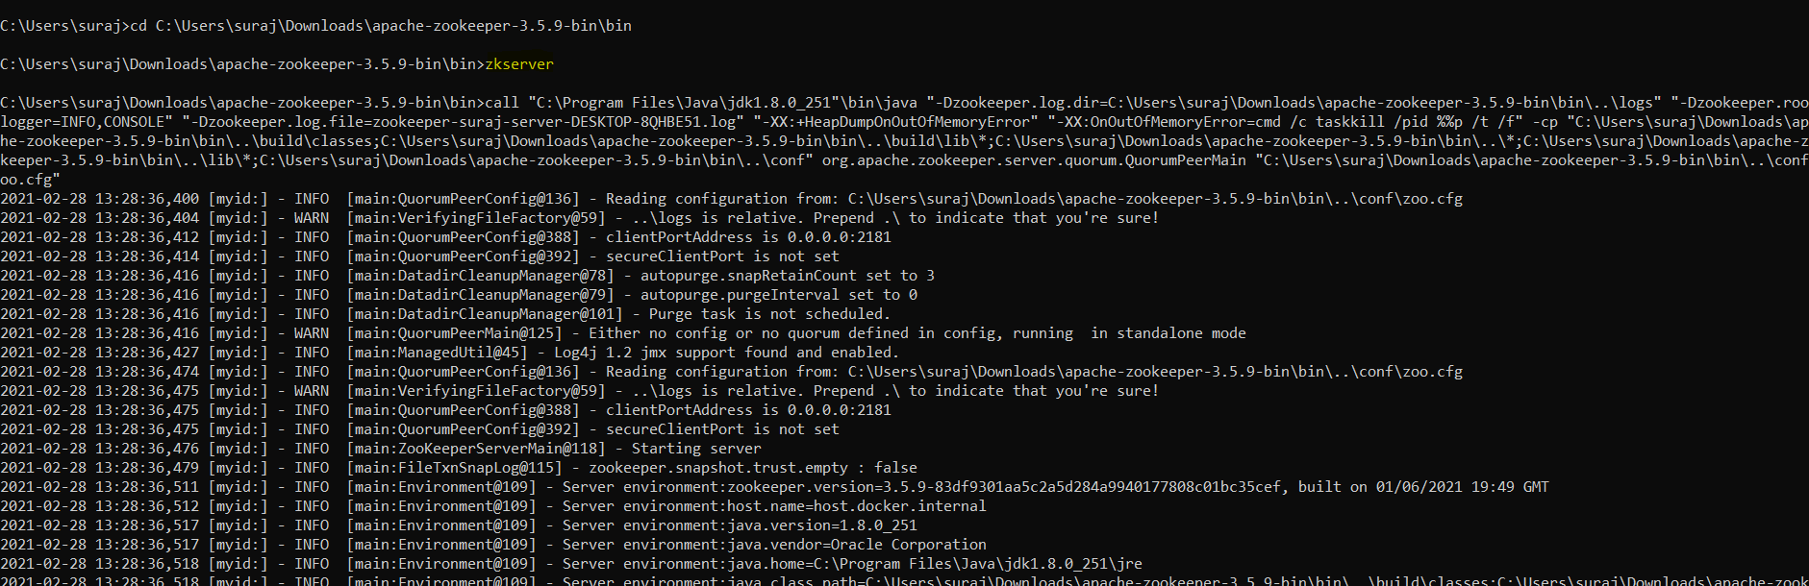

Thereafter go to the Kafka directory for starting the process of producer and consumer in Kafka.

Foremost navigate to the Kafka directory by using the below command.

C:\kafka_2.13-2.7.0>**cd bin**

C:\kafka_2.13-2.7.0\bin>**cd windows**

After typing the above commands create a topic to which producer can push the message and the subscriber could read the message.

C:\kafka_2.13-2.7.0\bin\windows>**kafka-topics.bat --create --zookeeper localhost:2181 --replication-factor 1 --partitions 1 --topic check**



Once the topic is created then create the producer at localhost 9092 with the same topic name as above.

C:\kafka_2.13-2.7.0\bin\windows>**kafka-console-producer.bat --broker-list localhost:9092 --topic check**



Once the producer is created then create a consumer to read the message from the topic. Below is the command for the same.

C:\kafka_2.13-2.7.0\bin\windows>**kafka-console-consumer.bat -bootstrap-server localhost:9092 -topic check**



From the above snapshot we can clearly confirm that the consumer is able to read all the messages in the topic check which is being pushed by the producer.

Moreover all the above snapshots have given us quite a simpler view of how zookeeper, topic, producer and consumer are linked to each other in this Kafka model.